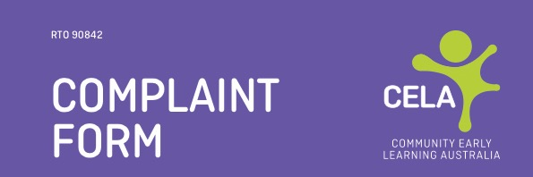

SECTION 1

Candidate making complaint to complete Section 1
Nature of complaint:
Candidate name:
Candidate signature: |  | Date:
Individual making the complaint is (check appropriate membership below)
The Learner The RTO Staff Member
The Trainer/assessor The Learner’s Supervisor
The Third-Party Delivering Education
If the complaint is being made against (check appropriate membership below)
The Learner The RTO Staff Member
The Trainer/assessor The Learner’s Supervisor
The Third-Party Delivering Education

SECTION 2

Staff member receiving this form to complete Section 2
Comments:
Staff member name:
Staff signature: |  | Date:
FORWARDED TO:
RTO Manager: | Training Manager: | Independent Review:

Date:

SECTION 3
Staff member conducting the investigation of the complaint is to attach a detailed report to this form.
RTO manager will take action according to Community Early Learning Australia’s Complaints Policy.
Although, the RTO will make every effort in resolving your complaint within 14 calendar days, however, if the resolution takes longer than 14 calendar days, you will be informed in writing. If you are not satisfied with the resolution outcome, you may lodge an appeal against the decision. The RTO’s appeal policy can be obtained from RTO’s website, www.cela.org.au
The RTO will provide an independent review if requested in writing.

